How to Open a Lost Form

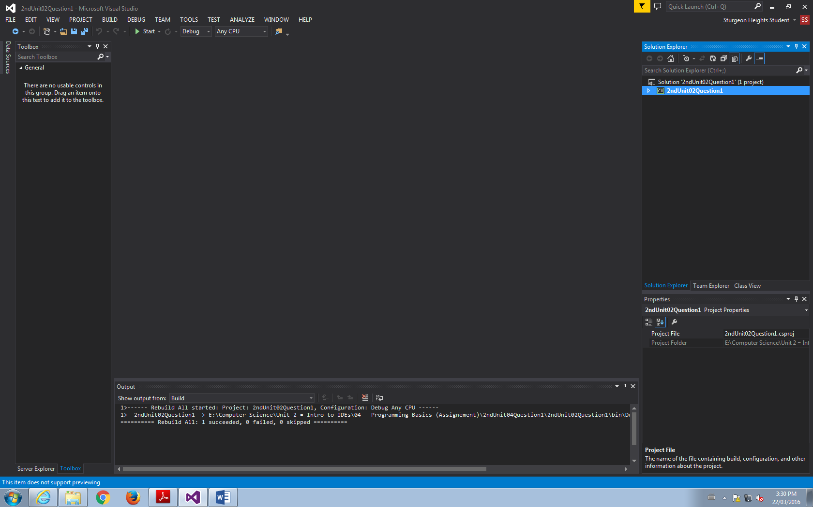

1. Click on the little triangle on the highlighted blue words (The Name of your File)

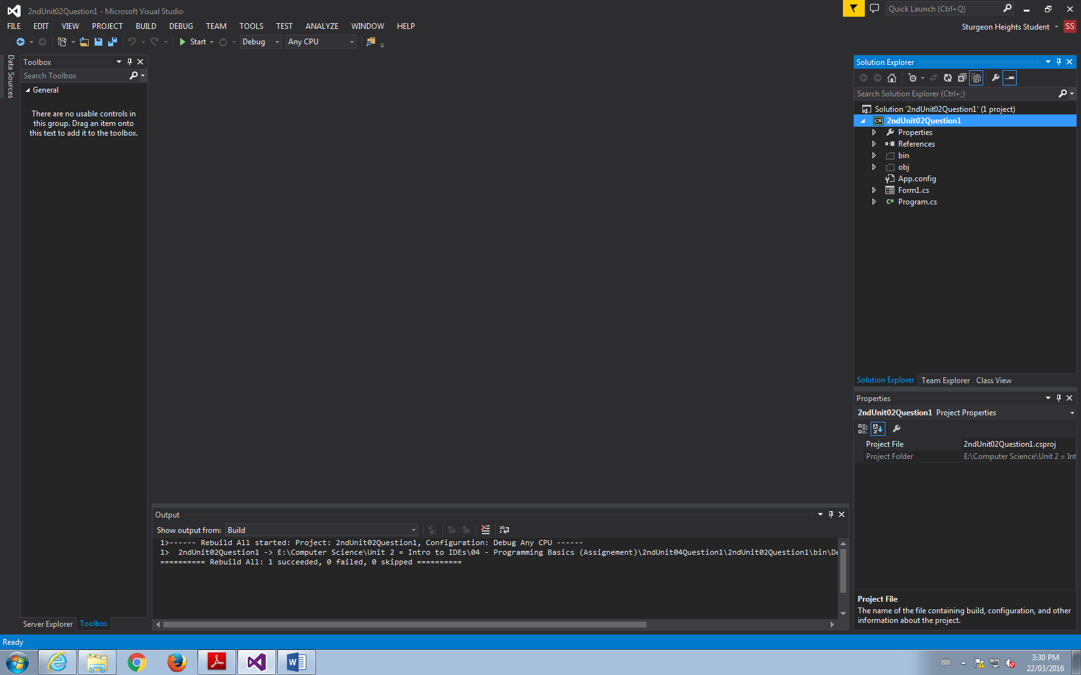

3. Double Click on Form1 (Or whatever the name of your lost form is)

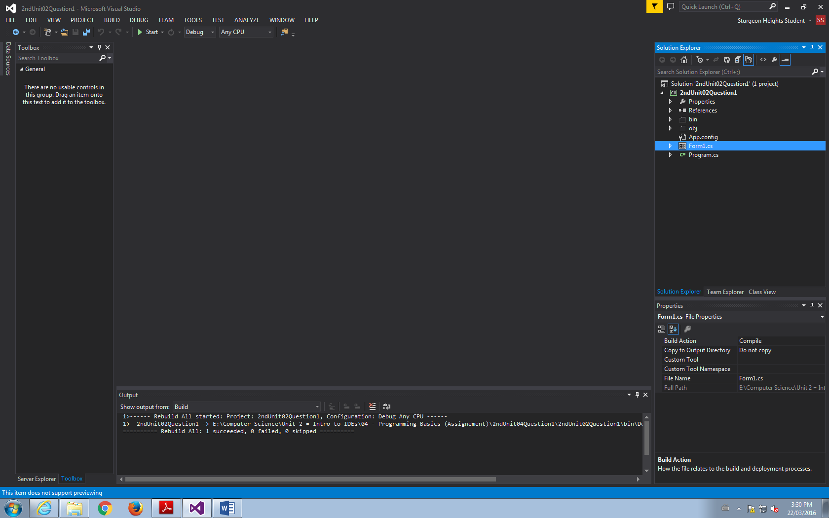

5. VOILA! ... then… IT IS DONE!

